|  |  |  |  |  |  |  |  |  |  |
| --- | --- | --- | --- | --- | --- | --- | --- | --- | --- |
| **Faculty of Information Technology** | | | | | | | | | |
| I declare that I am familiar with, and will abide to the Examination rules of CTU              **Signature** | **SUBJECT NAME: Business Programming**  **SUBJECT CODE:** PRG522 | | | | | | | | |
| **Formative Assessment 3 Duration**: 27 Days  **Date**:  12-10-2023  **Total Marks**: 100  **Total pages**: - | | | | **Examiner**:  Mr Junior Manganyi  **Moderator:** | | | | |
| **Student number** | | | | | | | | |
| 2 | 0 | 2 | 3 | 1 | 4 | 0 | 5 |  |
| **Surname**:  Moshoeshoe | | | | **Initials**: Leduma Tlotliso | | | / | % |
|  |  |  |  |  |  |  |  |  |  |

**Question 1:**

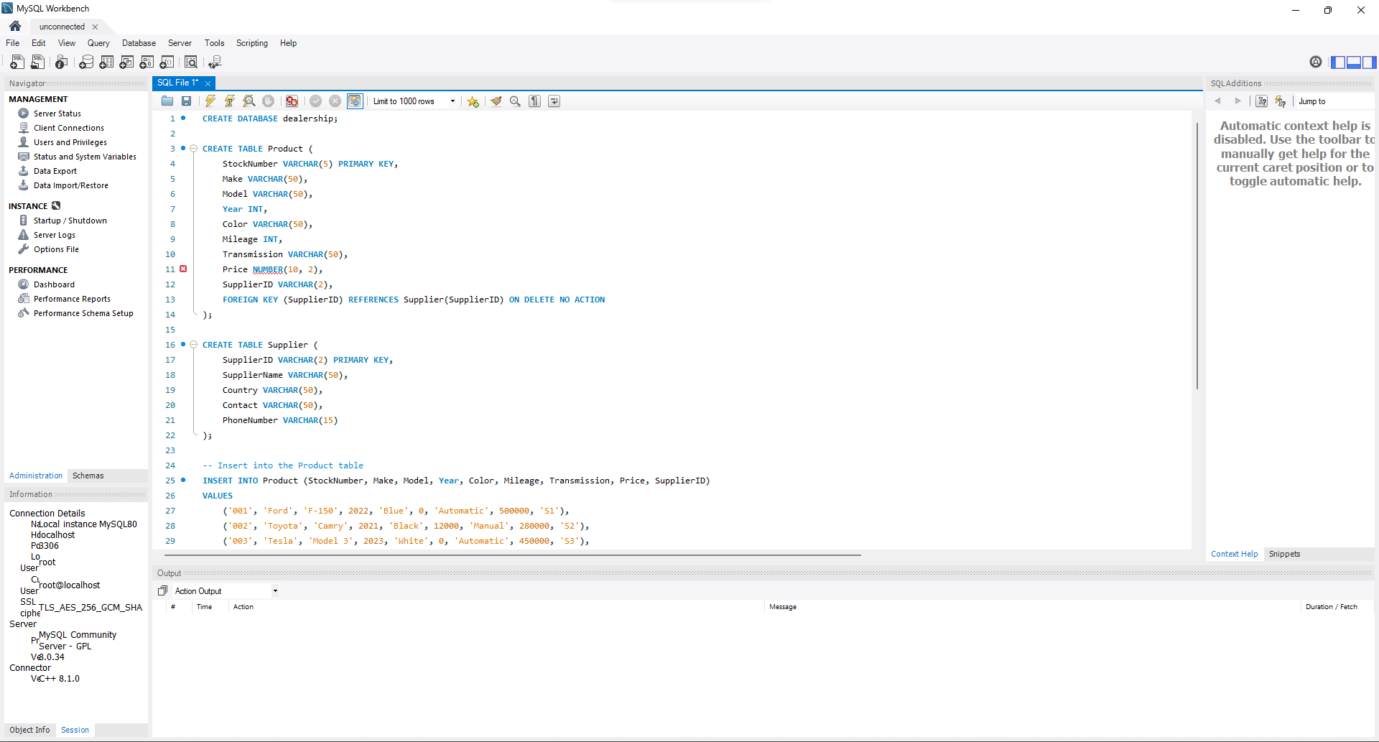

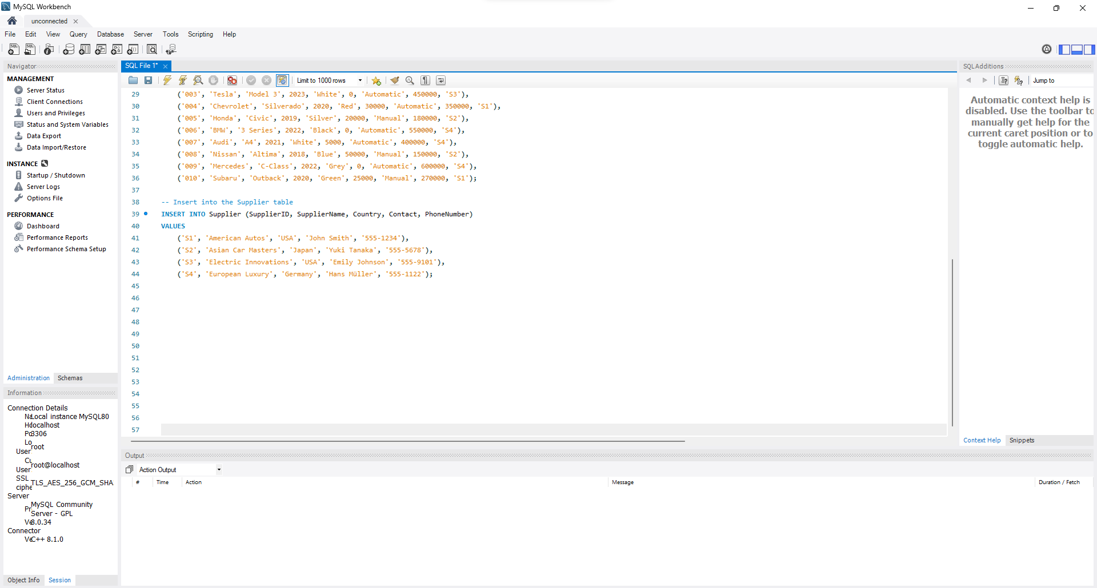

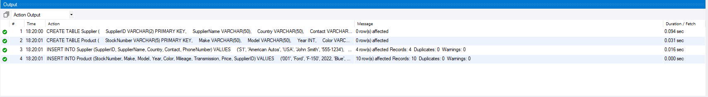

**Question 2:**

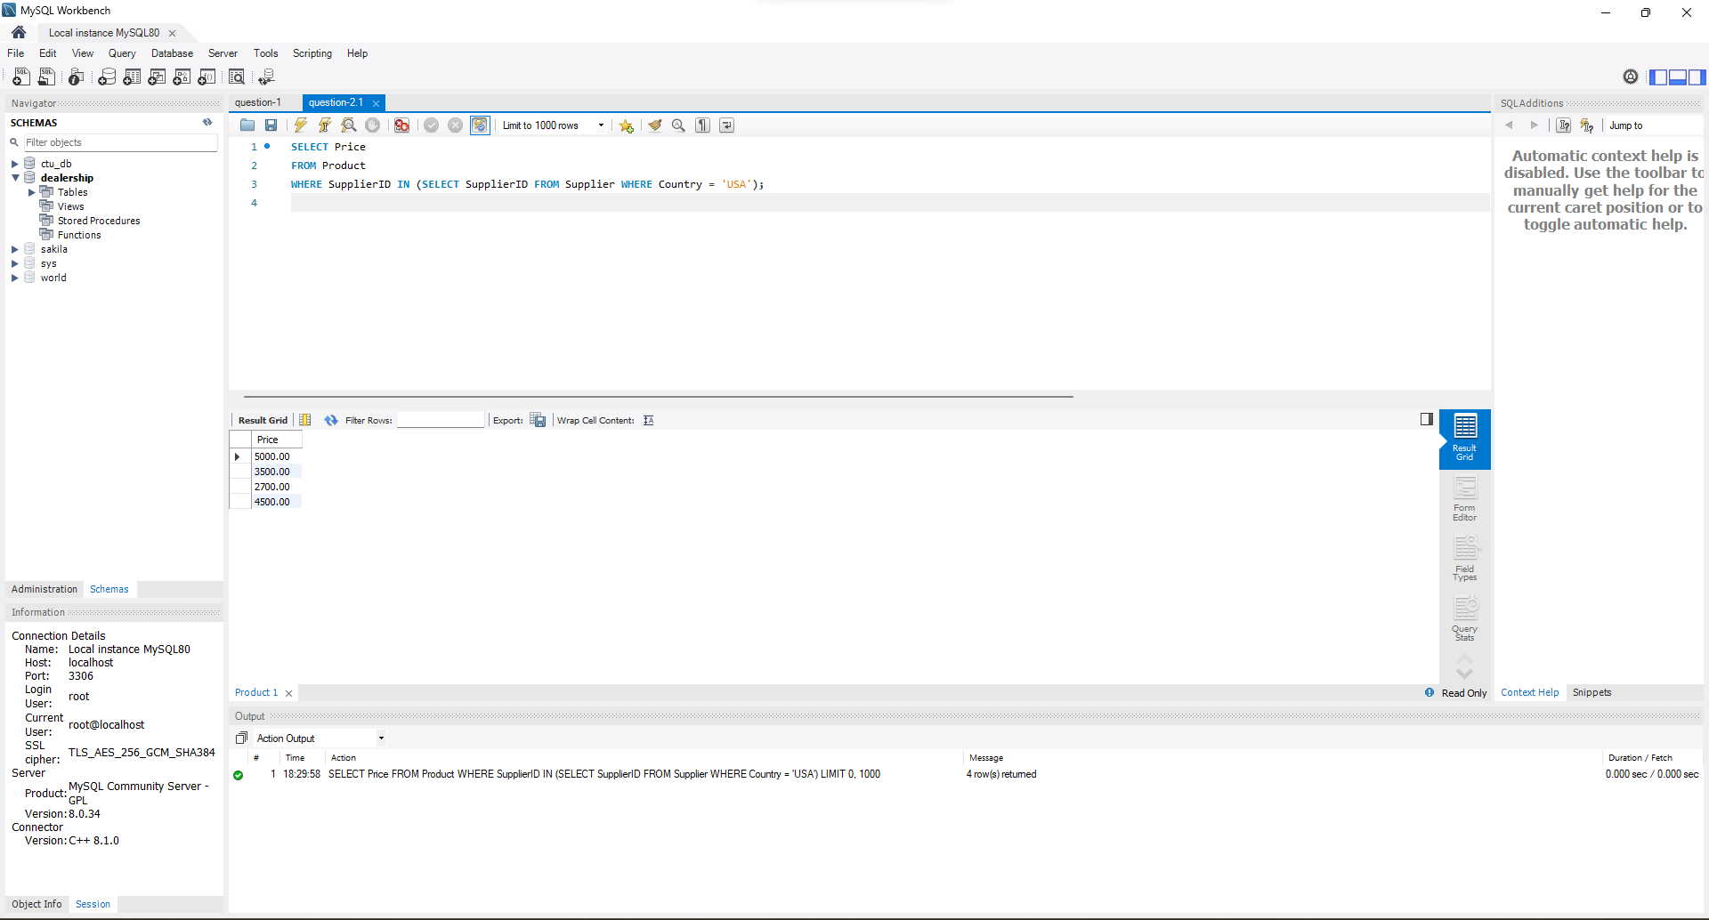

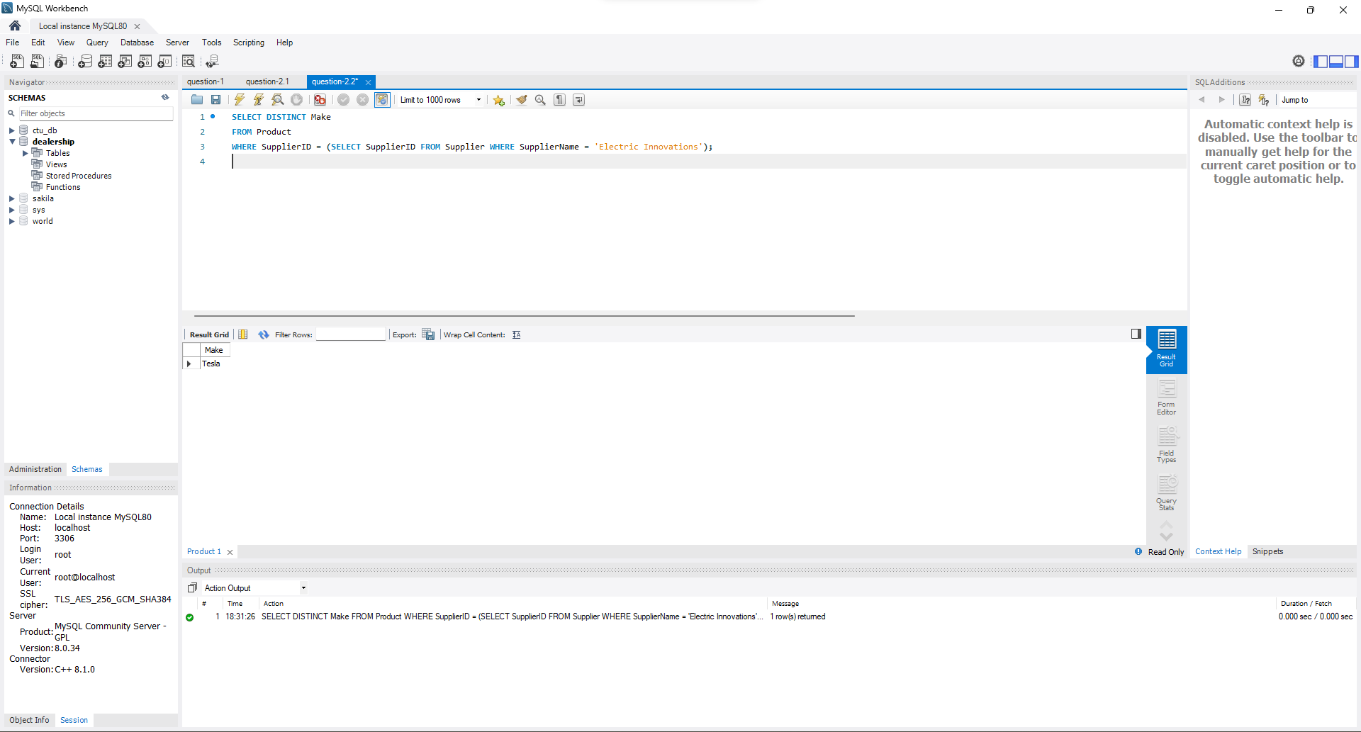

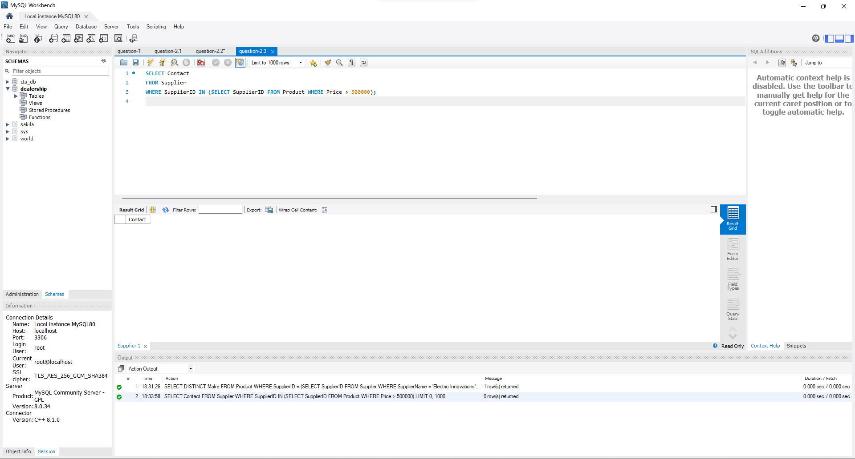

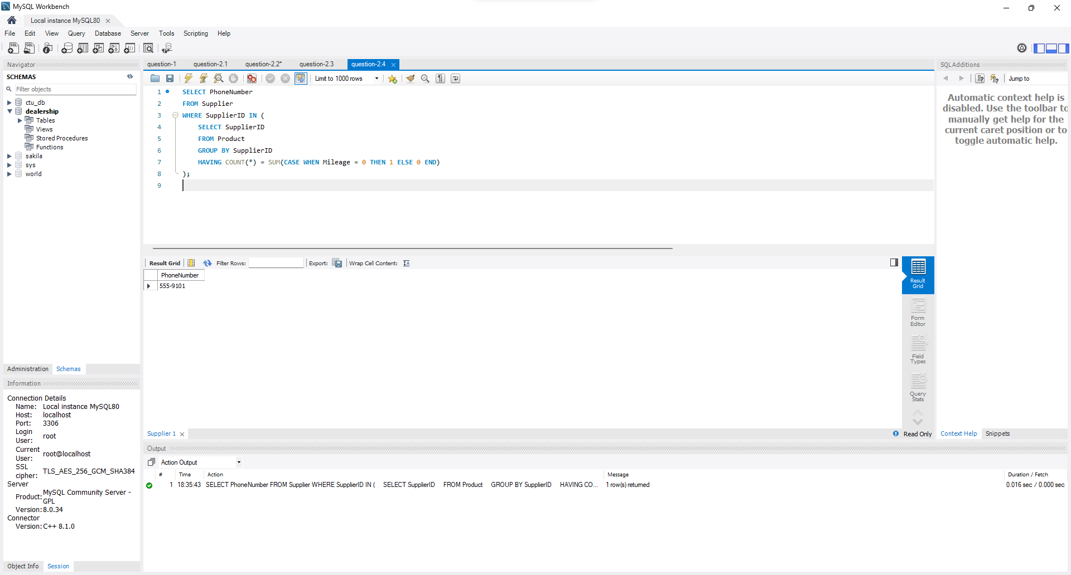

**Question 3:**

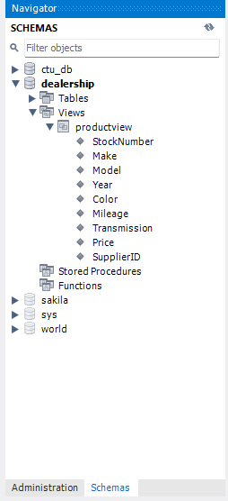

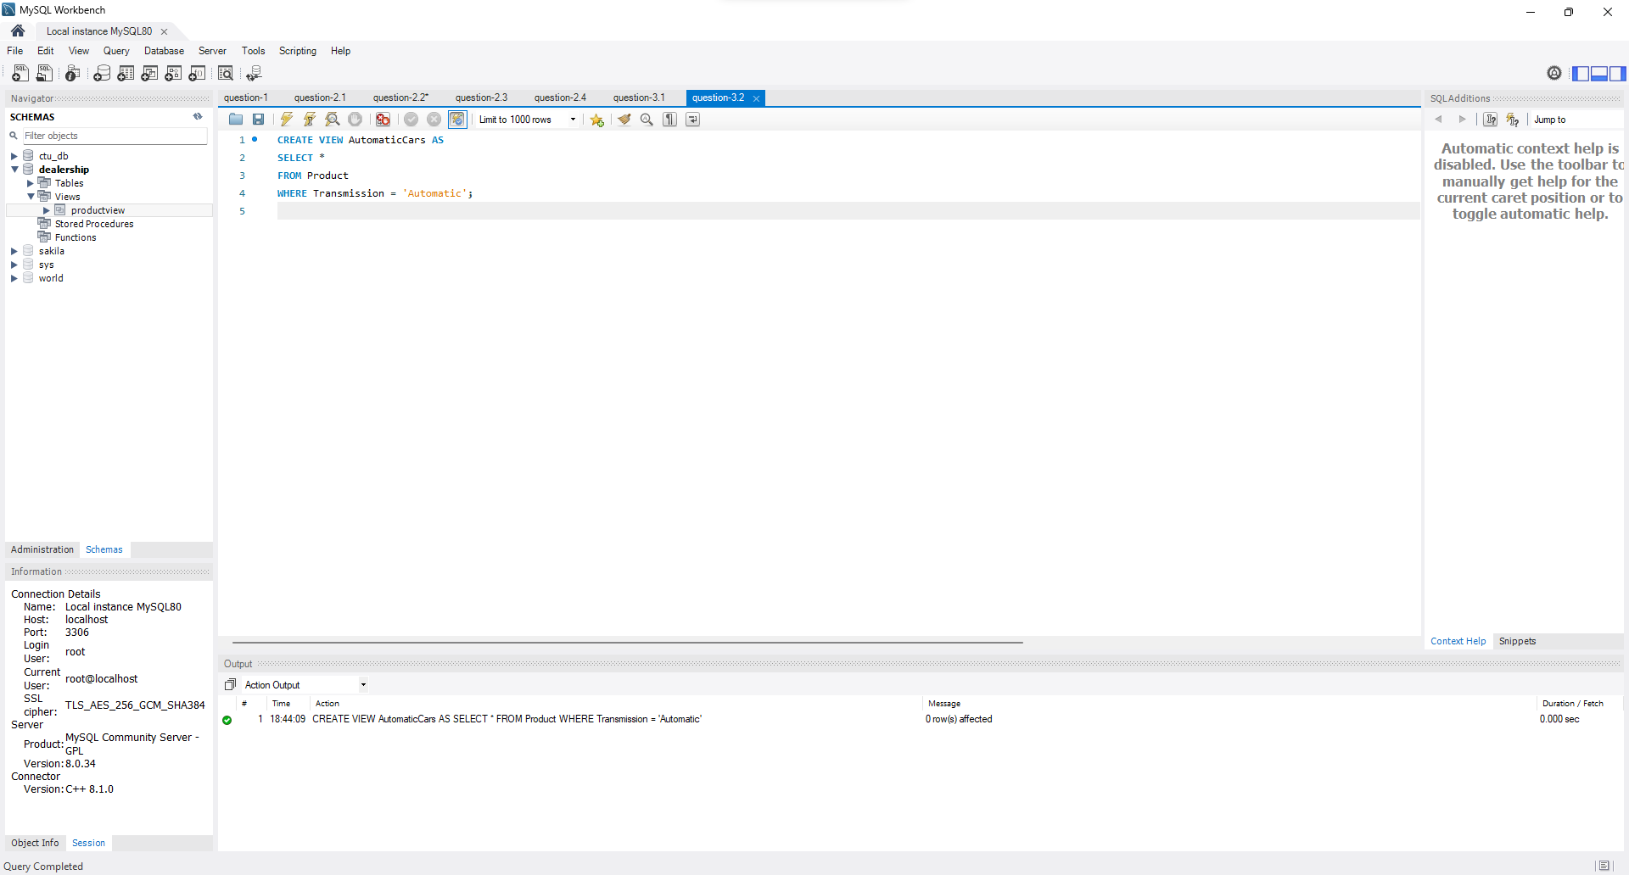

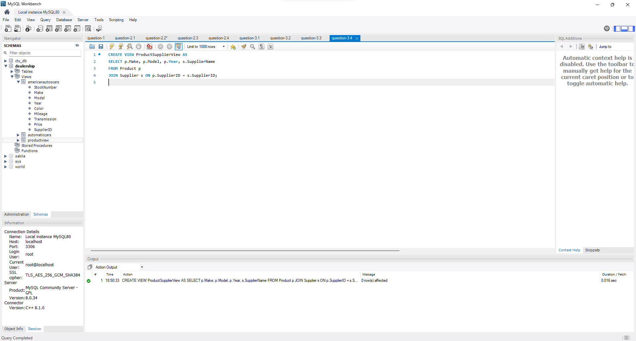

**Question 4:**

